Week 4 — Learner Workbook
Project Work Automation, Clean Code & Software Quality Engineering — Canadian Edition 2025

Week 4 — Capstone: Assemble and Defend
Learner Name: _________________________
Start Date: ___________________________
System Under Test (chosen Week 1, Day 1): _________________________________

Learning Goals
By the end of this week you will:
- Audit four weeks of work against the gates and produce a prioritised gap list.
- Close those gaps — finishing what exists rather than building anything new.
- Complete the pipeline by adding its final two stages, Deploy and Smoke.
- Assemble the four-week metrics report from your Carry-Forward Ledger.
- Defend the result from evidence, under questions.

1. What This Week Is
You are not starting a project this week. You have been building one since Week 1, Day 1, and this week you finish it. Nothing is discarded, nothing is rebuilt, and no new system is chosen. If you have arrived here with nothing to assemble, say so on Day 1 — the recovery path is the reference System Under Test with a reduced scope, and it only works if you speak early.
The difficulty this week moves from building to closing gaps and arguing from evidence, which is what a release actually is.
Day | Focus | Output
1 | Gap audit — every amber gate, uncovered criterion and deferred refactor | A written gap list, prioritised
2 | Close the gaps. Work the list; finish what exists | All gates green
3 | Complete the pipeline — add Deploy and Smoke | One green run through all eight stages
4 | Build the evidence — the four-week metrics report | docs/metrics-report.md
5 | Defend — fifteen minutes, then questions | Delivered defence
What am I still missing on Day 1? Write it here before you look at anything:

2. The Gap Audit
Go through every gate the program set and mark where you actually stand. A cell you cannot evidence is a gap, and it belongs on the list — not in a sentence saying you would have got to it.
Gate | Threshold | Where the evidence lives | Green?
Coverage | ≥ 80% | SonarQube Cloud / JaCoCo history | ☐
Maintainability | Grade A | SonarQube Cloud | ☐
Performance | p95 ≤ 500 ms | k6 or JMeter report | ☐
Error rate under load | < 1% | k6 or JMeter report | ☐
Critical CVEs | 0 | ZAP / Snyk / Trivy output | ☐
High CVEs | 0 | Same — max_high is what drives the gate | ☐
Branch coverage | ≥ 60% | Coverage report | ☐
Accessibility | ≥ 95 and 0 critical and 0 serious violations | Lighthouse score plus the axe report scripts/check-a11y.py reads | ☐
Functional criteria covered | 100% | docs/acceptance-criteria.md | ☐
The performance gate is a 95th percentile, not a mean. A mean of 400 ms hides a tail of two-second responses, and it is the tail your users feel.
Project Task 2.1 — The Gap List. Write docs/gap-list.md: every gap above, plus every deferred item in your refactor log, ranked by reader §2.6’s three axes — impact × likelihood × detectability — with each item carrying its score, an owner and a target day. Effort is a tiebreak, never the sort key, and a ranking you cannot defend out loud is not a ranking.

3. Completing the Pipeline
Six stages have arrived over Weeks 2 and 3. This week adds the last two.
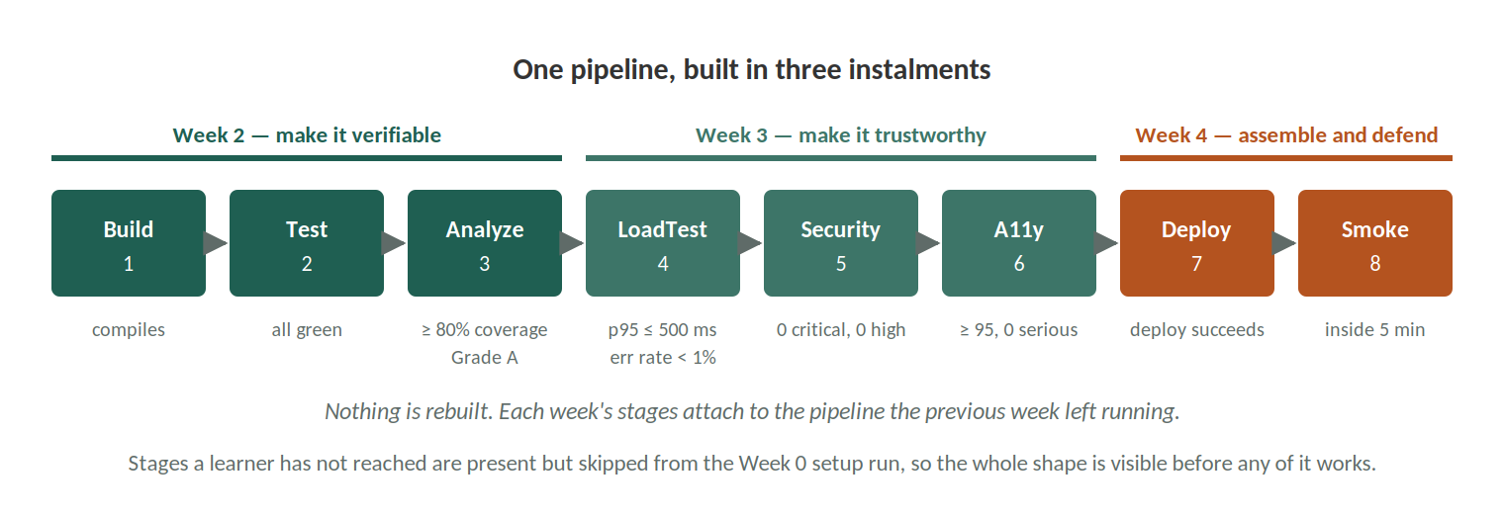
Figure 4 — The eight-stage pipeline, and the week each stage arrives
Build → Test → Analyze → LoadTest → Security → A11y → [Deploy] → [Smoke]
▲ ▲
added this week
Deploy pushes the built artifact to a staging target that is not your laptop, triggered by the pipeline rather than by you. Smoke is a small suite — under two minutes — proving the deployed thing is actually alive.
Project Task 3.1. Produce one pipeline run, from a single commit, in which all eight stages pass. Record the run URL:

Project Task 3.2. Write docs/pipeline.md: a diagram of all eight stages, and for each one what it gates on and what it produces. A gate that fires but leaves no artifact cannot be shown in a defence.
Project Task 2.2 — The Traceability Table. Complete the table in docs/acceptance-criteria.md: every functional criterion, the layer that tests it, the test that covers it, and whether it is green. 100% of functional criteria covered is a Week 4 exit gate, and this is the document that proves it.
Which criteria have no test, and is that a gap or a criterion that stopped being true?

Project Task 2.4 — The Release Summary. Write docs/release-summary.md: what ships, what does not, what the known risks are, and what you would tell somebody taking this over on Monday. One page.
Project Task 5.1 — The Handover Note. Write docs/handover.md: how to run it, how to run the tests, where the gates are configured, and the two things most likely to break first.

Knowledge Check
- Why must Deploy be pipeline-triggered rather than run by hand?
- What should the pipeline do if Smoke fails after a successful Deploy?
- Your coverage gate passes at 81%. What has it actually told you?

4. The Evidence
Your Carry-Forward Ledger has been collecting one row a week since Week 1. That trend is the metrics report — you are not writing a new document so much as finishing the one you have been keeping.
Project Task 2.3. Complete docs/metrics-report.md: each metric, its Week 1 baseline, its value now, and one sentence on what moved it.
Project Task 4.1. Add the measurement appendix — how each number was produced, so somebody could reproduce it without asking you.
Which number moved most, and do you know why?

5. The Defence
Fifteen minutes, then questions. What it must contain:
- Your System Under Test and the scope you set on Week 1, Day 1.
- The test architecture as built — which is rarely the one you designed in Week 2.
- Functional and non-functional results against the gates in §2.
- The four-week trend, from your ledger.
- What you would do next, and what you deliberately chose not to do.
Expect to be asked about a number you cannot explain. Find that number now:

Reflection
- Which quality attribute told you the most about your system that you did not already know?
- Where did you trade depth for runtime, and would you make that trade again?
- What would you do differently with two more weeks — and why that, rather than more tests?

6. Week 4 Deliverables
Deliverable | Where
Prioritised gap list | docs/gap-list.md
Traceability table, 100% of functional criteria | docs/acceptance-criteria.md
Four-week metrics report + measurement appendix | docs/metrics-report.md
Release summary | docs/release-summary.md
Pipeline documentation | docs/pipeline.md
Handover note | docs/handover.md
One green run through all eight stages | CI run URL
Fifteen-minute defence | Delivered live

7. Progress Checklist
Concept | I can… | Done
Gap auditing | Audit my own work against a gate and record what fails | ☐
Pipeline completion | Add Deploy and Smoke and prove the whole chain green | ☐
Evidence assembly | Turn four weeks of measurements into one argued report | ☐
Traceability | Show every functional criterion mapped to a passing test | ☐
Defence | Argue from evidence, and say plainly what I did not do | ☐

8. Continuous Quality After the Program
Continuous quality means treating testing as an ongoing practice rather than a phase you finish. Three things carry beyond this program:
- Treat automation code as production code — it is read more often than it is written.
- Keep the ledger habit. A trend is worth more than any single measurement.
- Re-examine your gates. A threshold nobody has questioned in a year is a threshold nobody is enforcing.
“Quality is never an accident; it is always the result of intelligent effort.” — John Ruskin

References (APA)
Beck, K. (2003). Test Driven Development: By Example. Addison-Wesley.
Humble, J., & Farley, D. (2010). Continuous Delivery: Reliable Software Releases through Build, Test, and Deployment Automation. Addison-Wesley.
Martin, R. C. (2008). Clean Code: A Handbook of Agile Software Craftsmanship. Prentice Hall.

Rehearsal — Project Task 6.1
Your assessment is a timed fifteen minutes. Reader §6 gives the structure; this is where you record that you actually ran it.
Rehearsed against a clock? | ☐ · Ran to: ______ minutes
What I cut to fit | ______________________________
The three questions my partner asked | 1. ______ 2. ______ 3. ______
The one I answered worst | ______________________________
Volunteer your weakest evidence before you are asked. The instructor guide is explicit that a learner who names a gap first scores above one who conceals it successfully — and the questions are where that is decided, not the slides.

